**CSC 1101 – Problem Solving and Programming Laboratory**

**Lab 8 – Trevor Trusty**

**25 points – Due February 11, 11pm**

**a)** Save this document with your name and the homework number somewhere in the file name.

**b)** Type/paste your answers into the document.

**c)** Submit this document and your .cpp file(s) to the Canvas item where you downloaded this document. Do not submit a zip file but individually attach your files.

**1) [8 points]** Remember that great application you wrote for *Heat Hunters* (Lab 6-3). Now they want you to add a data validation feature that restricts the entered temperature. Start with the key or your Lab 6-3 code. Prompt for and get from the user a temperature in Fahrenheit in the range -60 to 120. If the value is outside the range, print an error message (and nothing else except the application close). If the value is within the range, convert it to Celsius and show both values. Use formatted output manipulators (setw, left/right) to print the following two rows:

● Fahrenheit temperature

● Celsius temperature

And three columns:

● A left-justified label.

● A right-justified value.

● A left-justified units (output manipulators not needed here, but **don't** place one space before the units name to separate it from the second column).

Define constants for the column widths. Format all real numbers to two decimal places. Include the degree symbol in the output:

● Windows users – declare a constant for the degree symbol:

DEGREE_SYMBOL = (char) 167

Use the constant in the output.

● Mac OS users – copy the degree symbol above to your code.

Run the program five times with the following Fahrenheit values. What are the results?

|  |  |  |
| --- | --- | --- |
| Run | Fahrenheit | Result/Celsius |
| 1 | -82 | Invalid temp |
| 2 | -10 | -23.33 |
| 3 | 14 | -10.00 |
| 4 | 57 | 13.89 |
| 5 | 150 | Invalid temp |

*[your program code here]\**

**//==========================================================**

**//**

**// Title: Heat Hunters**

**// Course: CSC 1101**

**// Lab Number: Lab08-01**

**// Author: Trevor Trusty**

**// Date: 2/7/2019**

**// Description:**

**// User enters temperature in fahrenheit from -60 to 120 and the program**

**// converts it to degrees celcius.**

**//==========================================================**

**#include <conio.h> // For function getch()**

**#include <cstdlib> // For several general-purpose functions**

**#include <fstream> // For file handling**

**#include <iomanip> // For formatted output**

**#include <iostream> // For cin, cout, and system**

**#include <string> // For string data type**

**using namespace std; // So "std::cout" may be abbreviated to "cout"**

**int main() {**

**//declare variables**

**double fValue; //fahrenheit input**

**double result; //celcius output**

**//constants**

**const string TITLE = "Heat Hunters";**

**const int COL1 = 15;**

**const int COL2 = 10;**

**const char SYMBOL = 167; //Used to output degree symbol**

**cout << "Welcome to " << TITLE << endl;**

**cout << "--------------------------" << endl << endl;**

**//Promt user for temperature**

**cout << "Enter temperature in degrees fahrenheit, " << endl;**

**cout << "and the Cesius equivelent will be calculated for you." << endl;**

**cout << "\nTemperature(" << SYMBOL << "F): ";**

**cin >> fValue;**

**cout << endl;**

**if (fValue < -60 || fValue > 120) //fValue will only be used if btwn -60 and 120**

**{**

**cout << "Indvalid temperature entered." << endl;**

**cout << "Press any key to exit program...";**

**_getch();**

**}**

**else**

**{**

**//Convert to Celcius**

**result = fValue;**

**result -= 32;**

**result *= 5;**

**result /= 9.;**

**//Show table**

**cout << "====================================" << endl;**

**cout << fixed << setprecision(2);**

**cout << setw(COL1) << left << "Fahrenheit:";**

**cout << setw(COL2) << right << fValue << " " << SYMBOL << "F" << endl;**

**cout << setw(COL1) << left << "Celcius:";**

**cout << setw(COL2) << right << result << " " << SYMBOL << "C" << endl;**

**cout << "====================================" << endl;**

**cout << "\nEnd of " << TITLE << endl;**

**cout << "Press any key to exit...";**

**_getch();**

**}**

**}**

*[your program output here]\*\**

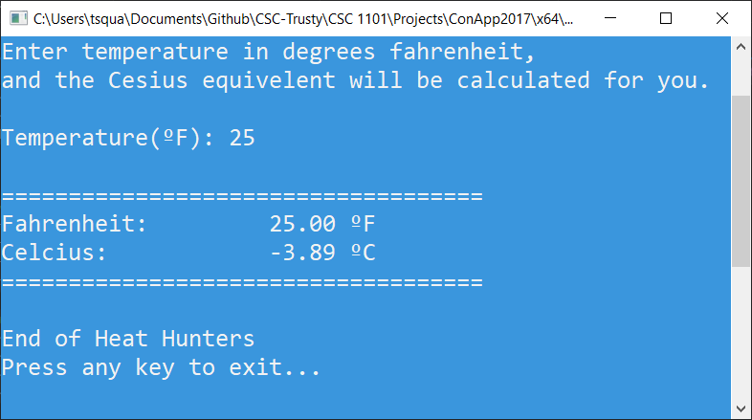

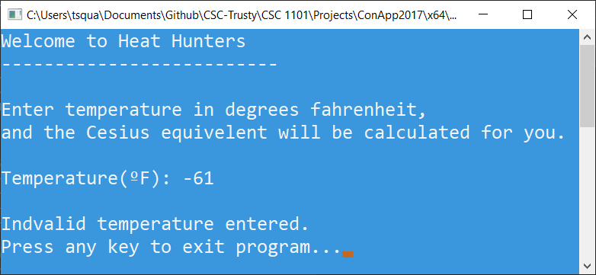

**2) [9 points]** You've been hired by *Best Bugs* to write a C++ console application that calculates and displays the cost of a customer’s purchase of one item. Prompt for and get from the user the quantity of the item purchased in the range 1-10. If the value is outside the range, print an error message (and nothing else except the application close). If the value is within the range, prompt for and get from the user a product character code per the following table:

|  |  |  |
| --- | --- | --- |
| Code | Product | Cost |
| c | Memory card | $30 |
| h | Headphones | $350 |
| m | Microwave | $54 |
| p | PlayStation | $300 |
| r | Router | $110 |

Use a **switch statement** to determine which code was entered and to set product and name variables for later calculation and printing. Assume a value of 'c' if the user didn't enter one of the five codes. Calculate the cost of the purchase. Use formatted output manipulators (setw, left/right) to print the following five rows:

● Quantity

● Product code

● Product name

● Product cost

● Purchase cost

And two columns:

● A left-justified label (including $ where necessary).

● A right-justified value.

Define constants for the column widths and product prices. Format all real numbers to two decimal places. Run the program five times with different product codes. Get a screenshot of each run.

*[your program code here]\**

**//==========================================================**

**//**

**// Title: Best Bugs**

**// Course: CSC 1101**

**// Lab Number: Lab08-02**

**// Author: Trevor Trusty**

**// Date: 2/7/2019**

**// Description:**

**// Calculates and displays the cost of a customer’s purchase of one item.**

**//**

**//==========================================================**

**#include <conio.h> // For function getch()**

**#include <cstdlib> // For several general-purpose functions**

**#include <fstream> // For file handling**

**#include <iomanip> // For formatted output**

**#include <iostream> // For cin, cout, and system**

**#include <string> // For string data type**

**using namespace std; // So "std::cout" may be abbreviated to "cout"**

**int main() {**

**//Declare variables**

**int amount; //Quantity of purchase**

**char type; //Type for input**

**string name; //Name of item**

**double total; //total of purchase**

**const string TITLE = "Best Bugs";**

**const int Col1 = 20;**

**const int Col2 = 15;**

**const double CPrice = 30;**

**const double HPrice = 350;**

**const double MPrice = 54;**

**const double PPrice = 300;**

**const double RPrice = 110;**

**cout << "Welcome to " << TITLE << endl;**

**cout << "--------------------------" << endl << endl;**

**cout << "Enter quantity of the item you are purchasing: ";**

**cin >> amount;**

**cout << endl;**

**if (amount < 1 || amount > 10)**

**{**

**cout << "Error: Unknown Quantity";**

**cout << "\nEnd of " << TITLE << endl;**

**cout << "Press any key to exit...";**

**_getch();**

**}**

**else**

**{**

**cout << "Enter product code (single character): ";**

**cin >> type;**

**cout << endl;**

**if (type != 'c' && type != 'h' && type != 'm' && type != 'p' && type != 'r')**

**{**

**total = CPrice * amount;**

**cout << "====================================" << endl;**

**cout << fixed << setprecision(2);**

**cout << setw(Col1) << left << "Quantity:";**

**cout << setw(Col2) << right << amount << endl;**

**cout << setw(Col1) << left << "Product code:";**

**cout << setw(Col2) << right << 'c' << endl;**

**cout << setw(Col1) << left << "Product name:";**

**cout << setw(Col2) << right << "Memory Card" << endl;**

**cout << setw(Col1) << left << "Product cost ($):";**

**cout << setw(Col2) << right << CPrice << endl;**

**cout << setw(Col1) << left << "Purchase Cost ($):";**

**cout << setw(Col2) << right << total << endl;**

**cout << "====================================" << endl;**

**cout << "\nEnd of " << TITLE << endl;**

**cout << "Press any key to exit...";**

**_getch();**

**}**

**else**

**{**

**switch (type)**

**{**

**case 'c': //Memory Card $30**

**total = CPrice * amount;**

**cout << "====================================" << endl;**

**cout << fixed << setprecision(2);**

**cout << setw(Col1) << left << "Quantity:";**

**cout << setw(Col2) << right << amount << endl;**

**cout << setw(Col1) << left << "Product code:";**

**cout << setw(Col2) << right << type << endl;**

**cout << setw(Col1) << left << "Product name:";**

**cout << setw(Col2) << right << "Memory Card" << endl;**

**cout << setw(Col1) << left << "Product cost ($):";**

**cout << setw(Col2) << right << CPrice << endl;**

**cout << setw(Col1) << left << "Purchase Cost ($):";**

**cout << setw(Col2) << right << total << endl;**

**cout << "====================================" << endl;**

**break;**

**case 'h':**

**//Headphones $350**

**total = HPrice * amount;**

**cout << "====================================" << endl;**

**cout << fixed << setprecision(2);**

**cout << setw(Col1) << left << "Quantity:";**

**cout << setw(Col2) << right << amount << endl;**

**cout << setw(Col1) << left << "Product code:";**

**cout << setw(Col2) << right << type << endl;**

**cout << setw(Col1) << left << "Product name:";**

**cout << setw(Col2) << right << "Headphones" << endl;**

**cout << setw(Col1) << left << "Product cost ($):";**

**cout << setw(Col2) << right << HPrice << endl;**

**cout << setw(Col1) << left << "Purchase Cost ($):";**

**cout << setw(Col2) << right << total << endl;**

**cout << "====================================" << endl;**

**break;**

**case 'm':**

**//Microwave $54**

**total = MPrice * amount;**

**cout << "====================================" << endl;**

**cout << fixed << setprecision(2);**

**cout << setw(Col1) << left << "Quantity:";**

**cout << setw(Col2) << right << amount << endl;**

**cout << setw(Col1) << left << "Product code:";**

**cout << setw(Col2) << right << type << endl;**

**cout << setw(Col1) << left << "Product name:";**

**cout << setw(Col2) << right << "Microwave" << endl;**

**cout << setw(Col1) << left << "Product cost ($):";**

**cout << setw(Col2) << right << MPrice << endl;**

**cout << setw(Col1) << left << "Purchase Cost ($):";**

**cout << setw(Col2) << right << total << endl;**

**cout << "====================================" << endl;**

**break;**

**case 'p':**

**//PlayStation $300**

**total = PPrice * amount;**

**cout << "====================================" << endl;**

**cout << fixed << setprecision(2);**

**cout << setw(Col1) << left << "Quantity:";**

**cout << setw(Col2) << right << amount << endl;**

**cout << setw(Col1) << left << "Product code:";**

**cout << setw(Col2) << right << type << endl;**

**cout << setw(Col1) << left << "Product name:";**

**cout << setw(Col2) << right << "PlayStation" << endl;**

**cout << setw(Col1) << left << "Product cost ($):";**

**cout << setw(Col2) << right << PPrice << endl;**

**cout << setw(Col1) << left << "Purchase Cost ($):";**

**cout << setw(Col2) << right << total << endl;**

**cout << "====================================" << endl;**

**break;**

**case 'r':**

**//Router $110**

**total = RPrice * amount;**

**cout << "====================================" << endl;**

**cout << fixed << setprecision(2);**

**cout << setw(Col1) << left << "Quantity:";**

**cout << setw(Col2) << right << amount << endl;**

**cout << setw(Col1) << left << "Product code:";**

**cout << setw(Col2) << right << type << endl;**

**cout << setw(Col1) << left << "Product name:";**

**cout << setw(Col2) << right << "Router" << endl;**

**cout << setw(Col1) << left << "Product cost ($):";**

**cout << setw(Col2) << right << RPrice << endl;**

**cout << setw(Col1) << left << "Purchase Cost ($):";**

**cout << setw(Col2) << right << total << endl;**

**break;**

**}**

**cout << "\nEnd of " << TITLE << endl;**

**cout << "Press any key to exit...";**

**_getch();**

**}**

**}**

**}**

*[your program output here]\*\**

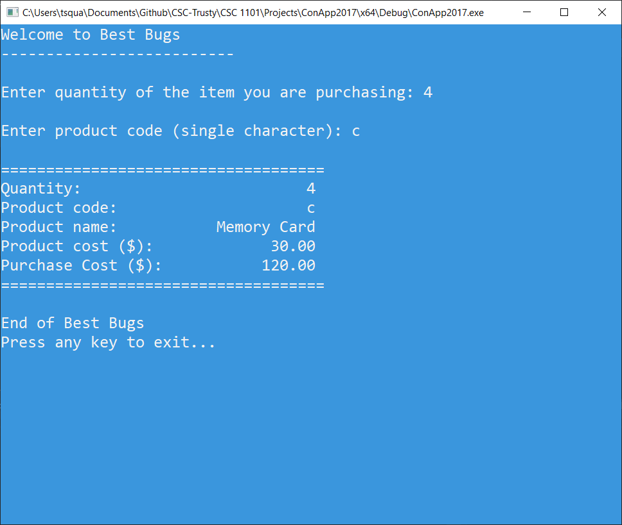

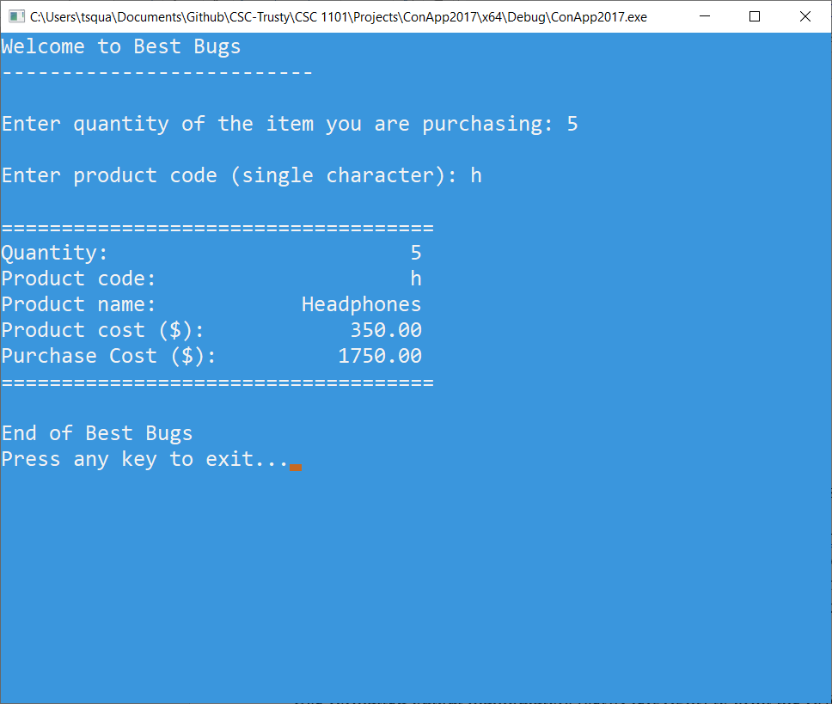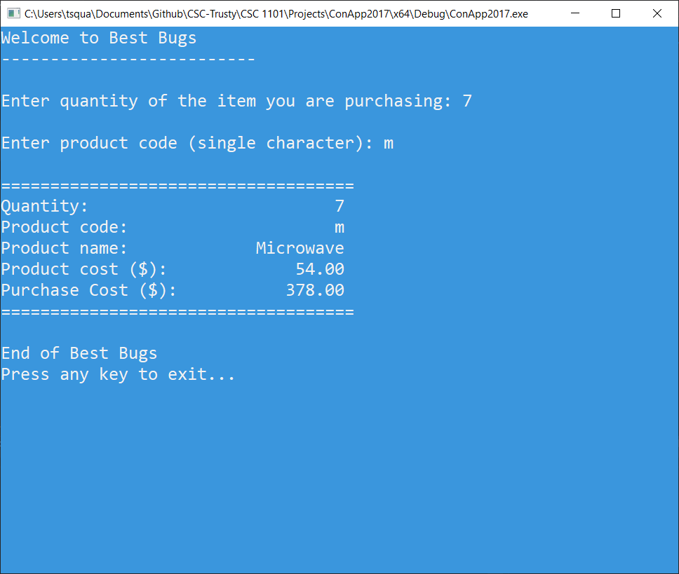

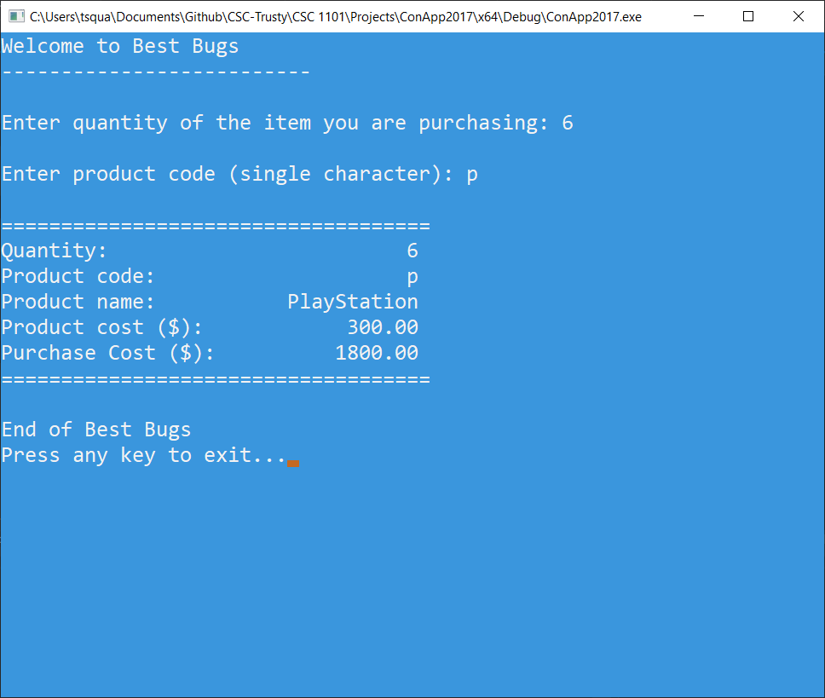

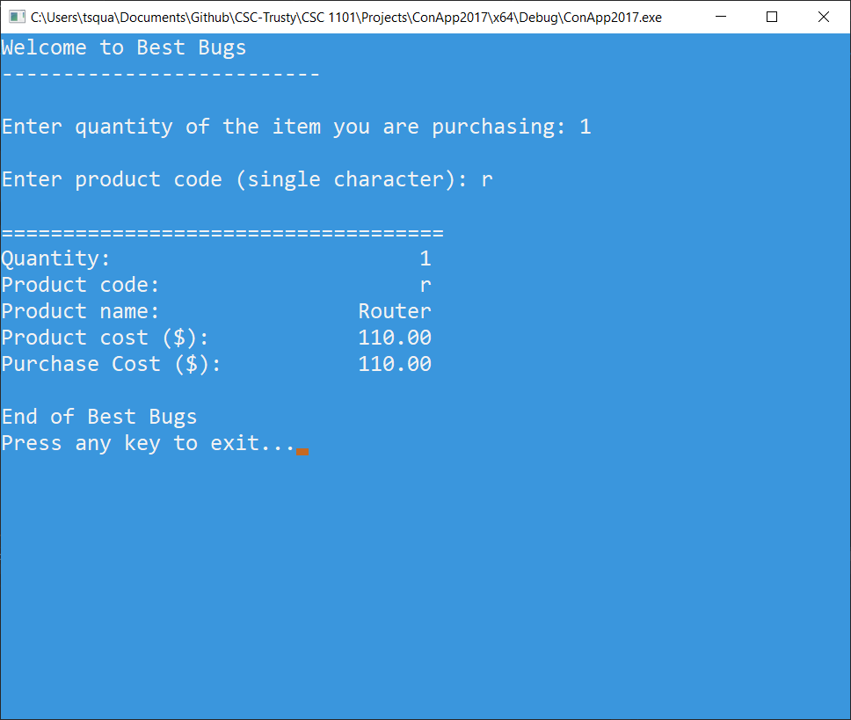

**3) [8 points]** You've been hired by *Letter Lovers* to write a C++ console application that analyzes the types of characters in a string entered by the user. Prompt for and get from the user a string containing at least ten characters. Use **getline()** to read the string. If the string contains fewer than ten characters, print an error message (and nothing else except the application close). If the string contains at least ten characters, test the third, sixth, and ninth characters to answer the following:

● Is the character a digit?

● Is the character alphanumeric?

● Is the character punctuation?

Use formatted output manipulators (setw, left/right) to print the rows and columns shown below. Define constants for the column widths. Run the program five times with different strings. Get a screenshot of each run. The output should look like this:

Welcome to Letter Lovers

------------------------

Enter a string with at least ten characters: Hello World!

Output key: zero-false; non-zero-true

String: Hello World!

Length: 12

Third character: l

-Digit? 0

-Alpha? 2

-Punct? 0

Sixth character:

-Digit? 0

-Alpha? 0

-Punct? 0

Ninth character: r

-Digit? 0

-Alpha? 2

-Punct? 0

End of Letter Lovers

*[your program code here]\**

**//==========================================================**

**//**

**// Title: Letter Lovers**

**// Course: CSC 1101**

**// Lab Number: Lab08-03**

**// Author: Trevor Trusty**

**// Date: 2/8/2019**

**// Description:**

**// Analyzes the types of characters in a string entered by the user,**

**// and displays information about the third, sixth, and ninth characters.**

**//**

**//==========================================================**

**#include <conio.h> // For function getch()**

**#include <cstdlib> // For several general-purpose functions**

**#include <fstream> // For file handling**

**#include <iomanip> // For formatted output**

**#include <iostream> // For cin, cout, and system**

**#include <string> // For string data type**

**using namespace std; // So "std::cout" may be abbreviated to "cout"**

**int main() {**

**string iString;**

**const int Col1 = 20;**

**const int Col2 = 15;**

**const string TITLE = "Letter Lovers";**

**cout << "Welcome to " << TITLE << endl;**

**cout << "--------------------------" << endl << endl;**

**cout << "Type a string of at least 10 characters: ";**

**getline(cin, iString);**

**cout << endl;**

**if (iString.length() < 10)**

**cout << "String must be at least 10 characters long" << endl;**

**else**

**{**

**cout << "Output key: zero-false; non-zero-true" << endl << endl;**

**cout << "====================================" << endl;**

**cout << setw(Col1) << left << "String:";**

**cout << setw(Col2) << right << iString << endl;**

**cout << setw(Col1) << left << "Length:";**

**cout << setw(Col2) << right << iString.length() << endl << endl;**

**cout << setw(Col1) << left << "Third Character:";**

**cout << setw(Col2) << right << iString.at(2) << endl;**

**cout << setw(Col1) << left << "-Digit?";**

**cout << setw(Col2) << right << isdigit(iString.at(2)) << endl;**

**cout << setw(Col1) << left << "-Alpha?";**

**cout << setw(Col2) << right << isalpha(iString.at(2)) << endl;**

**cout << setw(Col1) << left << "-Punct?";**

**cout << setw(Col2) << right << ispunct(iString.at(2)) << endl << endl;**

**cout << setw(Col1) << left << "6th Character:";**

**cout << setw(Col2) << right << iString.at(5) << endl;**

**cout << setw(Col1) << left << "-Digit?";**

**cout << setw(Col2) << right << isdigit(iString.at(5)) << endl;**

**cout << setw(Col1) << left << "-Alpha?";**

**cout << setw(Col2) << right << isalpha(iString.at(5)) << endl;**

**cout << setw(Col1) << left << "-Punct?";**

**cout << setw(Col2) << right << ispunct(iString.at(5)) << endl << endl;**

**cout << setw(Col1) << left << "9th Character:";**

**cout << setw(Col2) << right << iString.at(8) << endl;**

**cout << setw(Col1) << left << "-Digit?";**

**cout << setw(Col2) << right << isdigit(iString.at(8)) << endl;**

**cout << setw(Col1) << left << "-Alpha?";**

**cout << setw(Col2) << right << isalpha(iString.at(8)) << endl;**

**cout << setw(Col1) << left << "-Punct?";**

**cout << setw(Col2) << right << ispunct(iString.at(8)) << endl << endl;**

**cout << "====================================" << endl;**

**}**

**cout << "\nEnd of " << TITLE << endl;**

**cout << "Press any key to exit...";**

**_getch();**

**////Declare variables**

**//int amount; //Quantity of purchase**

**//char type; //Type for input**

**//string name; //Name of item**

**//double total; //total of purchase**

**//const int Col1 = 20;**

**//const int Col2 = 15;**

**//const double CPrice = 30;**

**//const double HPrice = 350;**

**//const double MPrice = 54;**

**//const double PPrice = 300;**

**//const double RPrice = 110;**

**//cout << "Welcome to " << TITLE << endl;**

**//cout << "--------------------------" << endl << endl;**

**//cout << "Enter quantity of the item you are purchasing: ";**

**//cin >> amount;**

**//cout << endl;**

**//if (amount < 1 || amount > 10)**

**//{**

**// cout << "Error: Unknown Quantity";**

**// cout << "\nEnd of " << TITLE << endl;**

**// cout << "Press any key to exit...";**

**// _getch();**

**//}**

**//else**

**//{**

**// cout << "Enter product code (single character): ";**

**// cin >> type;**

**// cout << endl;**

**// if (type != 'c' && type != 'h' && type != 'm' && type != 'p' && type != 'r')**

**// {**

**// total = CPrice * amount;**

**// cout << "====================================" << endl;**

**// cout << fixed << setprecision(2);**

**// cout << setw(Col1) << left << "Quantity:";**

**// cout << setw(Col2) << right << amount << endl;**

**// cout << setw(Col1) << left << "Product code:";**

**// cout << setw(Col2) << right << 'c' << endl;**

**// cout << setw(Col1) << left << "Product name:";**

**// cout << setw(Col2) << right << "Memory Card" << endl;**

**// cout << setw(Col1) << left << "Product cost ($):";**

**// cout << setw(Col2) << right << CPrice << endl;**

**// cout << setw(Col1) << left << "Purchase Cost ($):";**

**// cout << setw(Col2) << right << total << endl;**

**// cout << "====================================" << endl;**

**// cout << "\nEnd of " << TITLE << endl;**

**// cout << "Press any key to exit...";**

**// _getch();**

**// }**

**// else**

**// {**

**// switch (type)**

**// {**

**// case 'c': //Memory Card $30**

**// total = CPrice * amount;**

**// cout << "====================================" << endl;**

**// cout << fixed << setprecision(2);**

**// cout << setw(Col1) << left << "Quantity:";**

**// cout << setw(Col2) << right << amount << endl;**

**// cout << setw(Col1) << left << "Product code:";**

**// cout << setw(Col2) << right << type << endl;**

**// cout << setw(Col1) << left << "Product name:";**

**// cout << setw(Col2) << right << "Memory Card" << endl;**

**// cout << setw(Col1) << left << "Product cost ($):";**

**// cout << setw(Col2) << right << CPrice << endl;**

**// cout << setw(Col1) << left << "Purchase Cost ($):";**

**// cout << setw(Col2) << right << total << endl;**

**// cout << "====================================" << endl;**

**// break;**

**// case 'h':**

**// //Headphones $350**

**// total = HPrice * amount;**

**// cout << "====================================" << endl;**

**// cout << fixed << setprecision(2);**

**// cout << setw(Col1) << left << "Quantity:";**

**// cout << setw(Col2) << right << amount << endl;**

**// cout << setw(Col1) << left << "Product code:";**

**// cout << setw(Col2) << right << type << endl;**

**// cout << setw(Col1) << left << "Product name:";**

**// cout << setw(Col2) << right << "Headphones" << endl;**

**// cout << setw(Col1) << left << "Product cost ($):";**

**// cout << setw(Col2) << right << HPrice << endl;**

**// cout << setw(Col1) << left << "Purchase Cost ($):";**

**// cout << setw(Col2) << right << total << endl;**

**// cout << "====================================" << endl;**

**// break;**

**// case 'm':**

**// //Microwave $54**

**// total = MPrice * amount;**

**// cout << "====================================" << endl;**

**// cout << fixed << setprecision(2);**

**// cout << setw(Col1) << left << "Quantity:";**

**// cout << setw(Col2) << right << amount << endl;**

**// cout << setw(Col1) << left << "Product code:";**

**// cout << setw(Col2) << right << type << endl;**

**// cout << setw(Col1) << left << "Product name:";**

**// cout << setw(Col2) << right << "Microwave" << endl;**

**// cout << setw(Col1) << left << "Product cost ($):";**

**// cout << setw(Col2) << right << MPrice << endl;**

**// cout << setw(Col1) << left << "Purchase Cost ($):";**

**// cout << setw(Col2) << right << total << endl;**

**// cout << "====================================" << endl;**

**// break;**

**// case 'p':**

**// //PlayStation $300**

**// total = PPrice * amount;**

**// cout << "====================================" << endl;**

**// cout << fixed << setprecision(2);**

**// cout << setw(Col1) << left << "Quantity:";**

**// cout << setw(Col2) << right << amount << endl;**

**// cout << setw(Col1) << left << "Product code:";**

**// cout << setw(Col2) << right << type << endl;**

**// cout << setw(Col1) << left << "Product name:";**

**// cout << setw(Col2) << right << "PlayStation" << endl;**

**// cout << setw(Col1) << left << "Product cost ($):";**

**// cout << setw(Col2) << right << PPrice << endl;**

**// cout << setw(Col1) << left << "Purchase Cost ($):";**

**// cout << setw(Col2) << right << total << endl;**

**// cout << "====================================" << endl;**

**// break;**

**// case 'r':**

**// //Router $110**

**// total = RPrice * amount;**

**// cout << "====================================" << endl;**

**// cout << fixed << setprecision(2);**

**// cout << setw(Col1) << left << "Quantity:";**

**// cout << setw(Col2) << right << amount << endl;**

**// cout << setw(Col1) << left << "Product code:";**

**// cout << setw(Col2) << right << type << endl;**

**// cout << setw(Col1) << left << "Product name:";**

**// cout << setw(Col2) << right << "Router" << endl;**

**// cout << setw(Col1) << left << "Product cost ($):";**

**// cout << setw(Col2) << right << RPrice << endl;**

**// cout << setw(Col1) << left << "Purchase Cost ($):";**

**// cout << setw(Col2) << right << total << endl;**

**// break;**

**// }**

**// cout << "\nEnd of " << TITLE << endl;**

**// cout << "Press any key to exit...";**

**// _getch();**

**// }**

**//}**

**}**

*[your program output here]\*\**

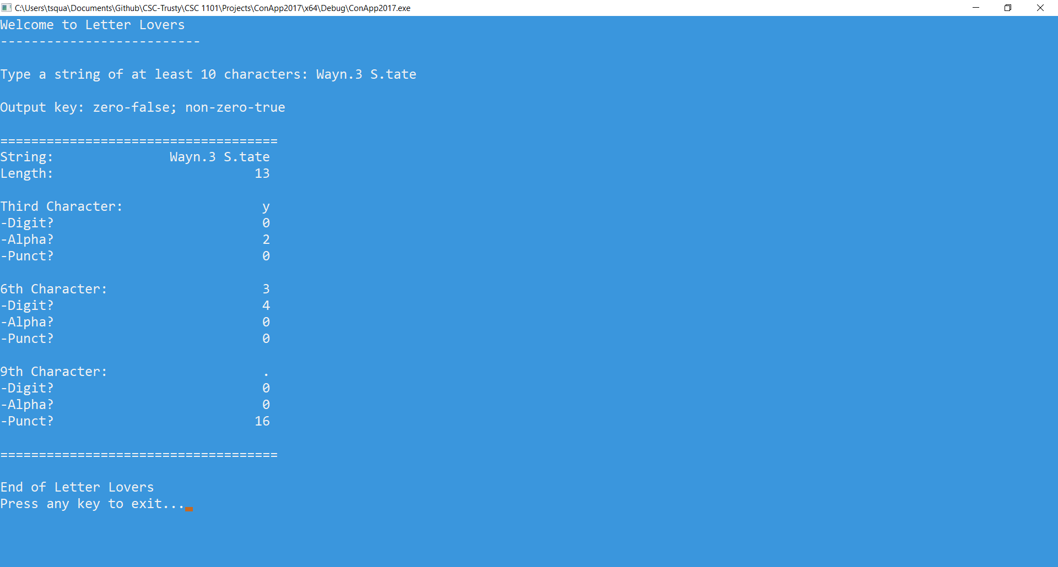

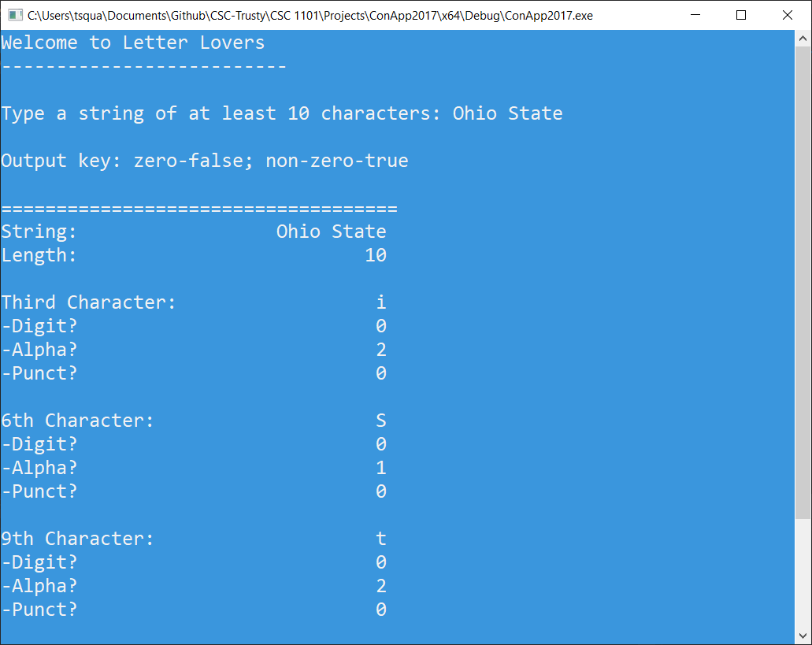

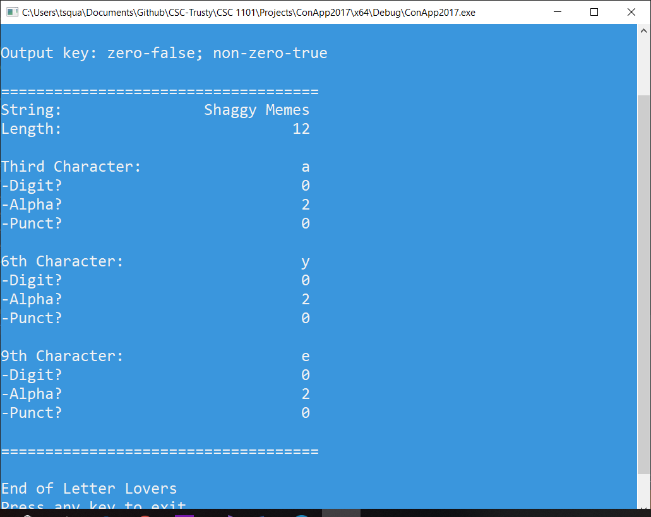

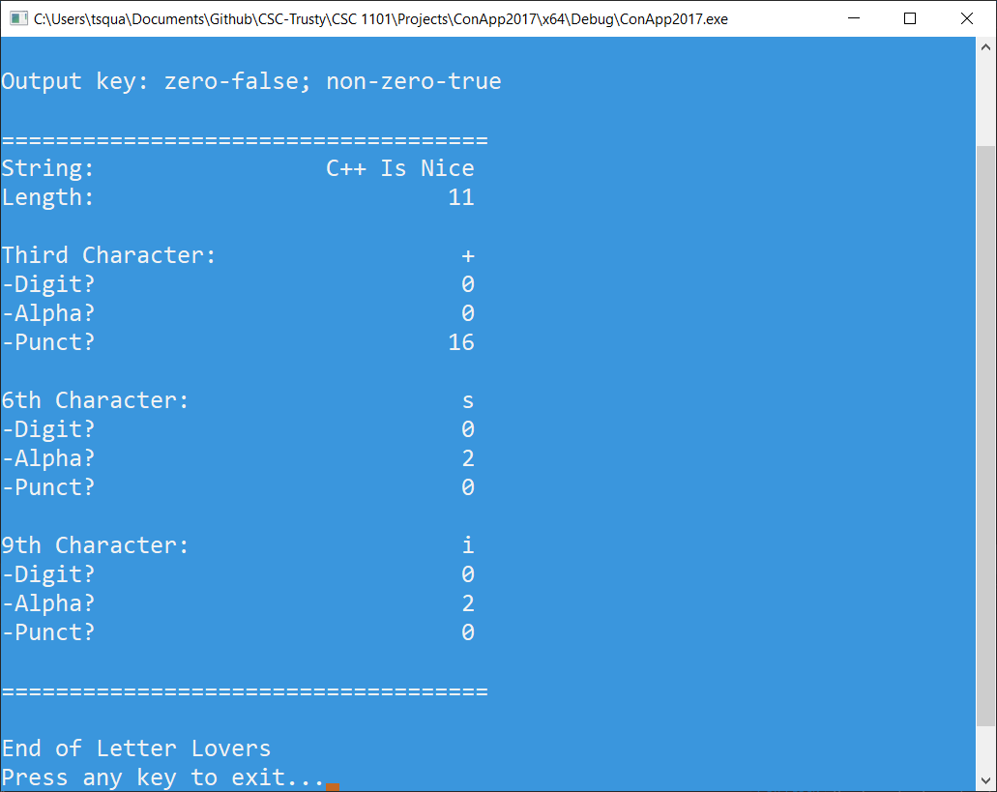

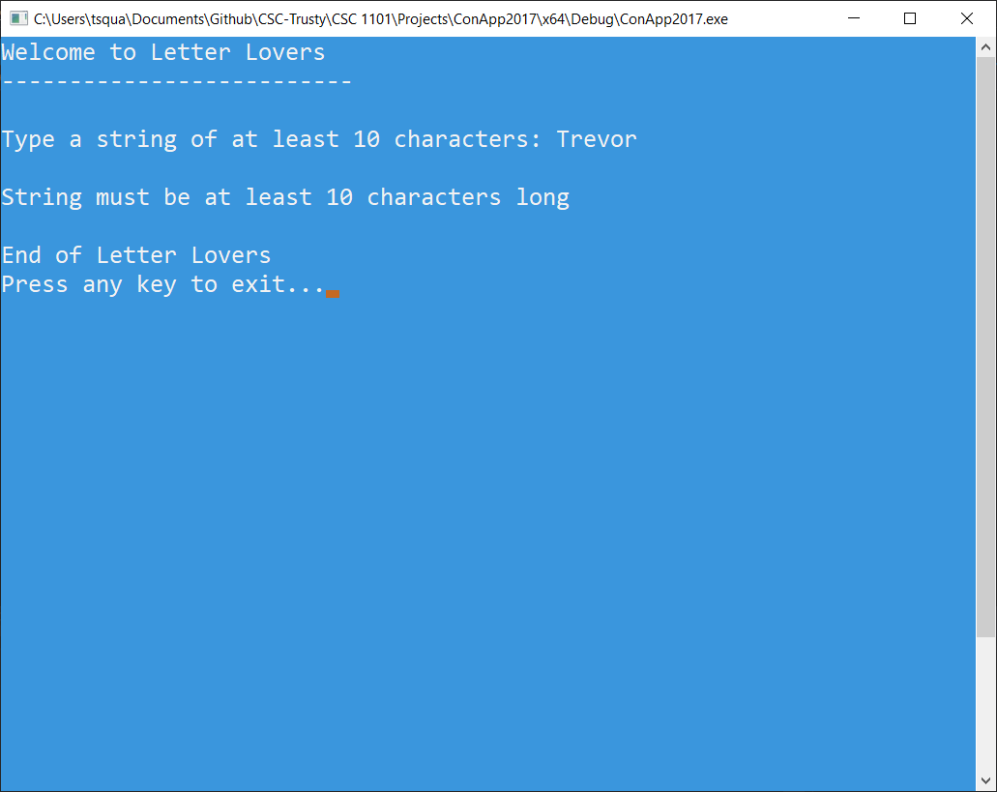

* **Copying-and-pasting Visual C++ code to a Word document**

1) From within the Visual C++ program, press **CTRL-A** and press **CTRL-C**.

2) From within the Word document, press **CTRL-V**.

** **Copying-and-pasting Visual C++ console application output to a Word document**

1) From the Visual C++ console, press **ALT-PrintScreen**.

2) From within the Word document, press **CTRL-V**.